Q) What is the Git Flow Branching Strategy?
Ans: -
- Master branch
Development Branch
Feature Branch

Pros: -
- It allows for Parelle development to protect the production branch code means the main/ master branch remains same.
- And the Developer works on the multiple separate branches.
(The various multiple separate branches it makes easier to work into the organization).

Cons: -
- Developer work on the multiple separate branches so it difficult to manage these branches it’s difficult to manage to merger the code into the devolvement branch to main/master branch.
- To Resolve this issue developer 1st need to create the release branch and make sure that any final work is also merged into the development branch then finally release branch merge into the final branch.
Development -> Feature Branch( n number of branch ) -> Release branch -> Master branch .

- When the change are done and its go to the test case and the test case are failes

Q) what is multibranch pipeline?
Ans:- The multibranch pipeline type of project that enable you to implement the different jenkinsfile for different branch of same project. The multibranch pipeline project, Jenkins Automatically manage and execute pipeline for branch which contained the Jenkins file in source controller.

Q) Why we go with the multibranch pipeline ?
Ans:- With the help of multibranch pipeline you can reduce the dependencies .

How its work Multibranch pipeline ?
Ans:-
- Its fetch the git repository
- Checking the Jenkins file under the branch .
- If branch it find then create the job or configure the job and then build the job.
- If not found then show the msg ‘jenkinsfile’ are not found.
Note :- The multibranch pipeline its create the folder structure for a Job.

Behavior:- Setting for GitFlow Branching Strategy.
- Filter By Name (with wildcard )
- Include: - Include Nothing but the which branch you need to trigger in multibranch pipeline.

- Exclude: - Exclude nothing but the which branch you do not want to execute while running the multibranch pipeline.
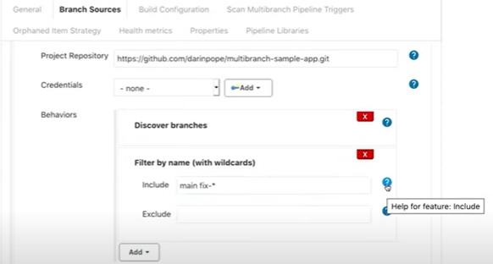
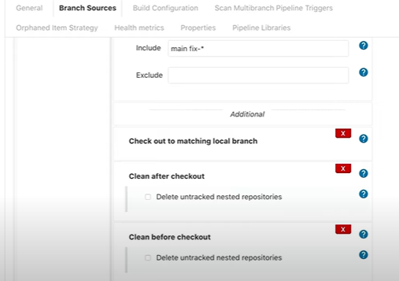

MultiBranch Pipeline With GitHub flow Branching Strategy.

Steps: -
- GitHub -> Profile -> Setting -> Developer Setting -> GitHub Apps -> New Github Apps -> Now enter the GitHub password.

Set Below Parameter :-
- Give the GitHub App Name: - You can give Any name .
- Home Page Url (GitHub Url): - https://github.com/ankupsatpute
- Set the WebHook Url (Jenkins url): - https://localhost:8080/github-webhook/

Set up the Repository Permission: -
https://api.github.com

Administration -> Read and Write.
Checks -> Read and Write.
Contents -> Read only.
Metadata -> Read only.
Pull requests -> Read only.
Commit statuses -> Read and Write.
Webhooks-> Read and Write.

Set up Origination permissions: - Nothing To do Here leave as it is.

Set up User permissions: - Nothing To do Here leave as it is

Set Up Scribe to Event: -
- Check run
- Check suite
- Pull request
- Push
- Repository
CREATE GITHUBAPP

Step 2:
Once you Create the GITHUB App you can get the below details.

Owned by: @ankupsatpute
App ID: 282022
Client ID: Iv1.865915003215102e

Then You Can generate the Private Key.

Step 3: -

Click on the INSTALL APP Section: -
Now you can be able to see your created GITHUB APP name.

Here , you can see two options
- All repository
- Only Select Repository .

Note: - For Security Purpose we can choose only Select repository .

Click on INSTALL.

Step 4: -

Set up the Credential on Jenkins Dashboard.

- Go to the Jenkins dashboard -> Manage Jenkins -> Manage Credentials -> Global->
Add Credentials.
- Choose GITHUB App.

Note :- Before add this private key into the Jenkins credentials section you need to convert this key using below command.

openssl pkcs8 -topk8 -inform PEM -outform PEM -in current-key.pem -out new-key.pem -nocrypt
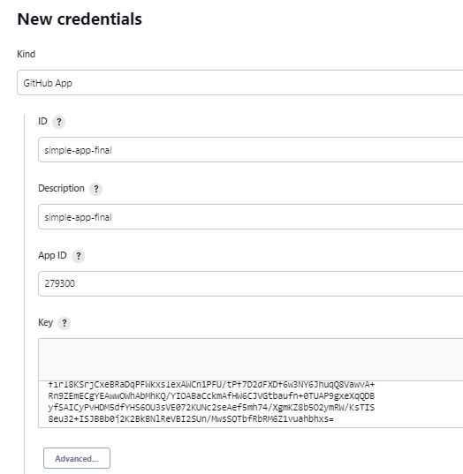

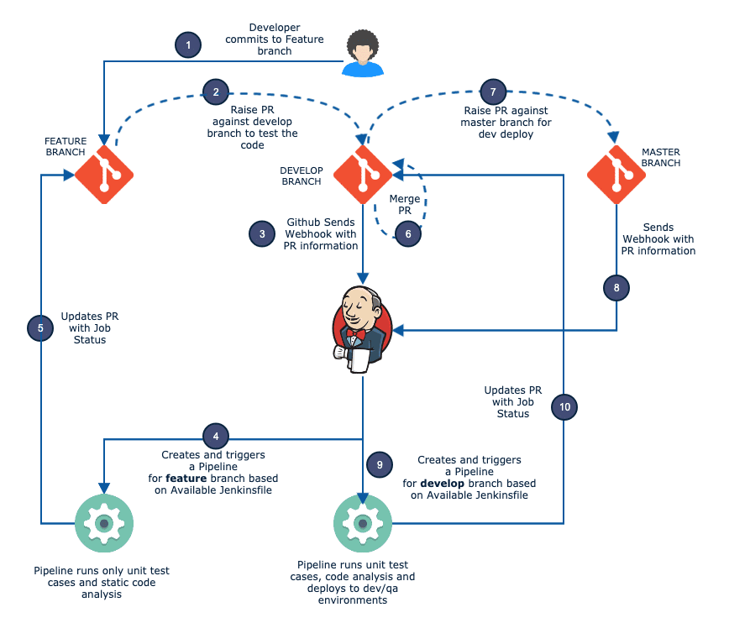

How Jenkins Trigger Automatic Web Hook Pull Request tiggger and Approved merged the Branch.

1)Go to Manange Jenkins --> Manage Plugins.
2)Click on the available tab at the top and search for Github Pull Request Builder. Select the plugin using the checkbox and click Install without restart as shown in the image below.
3)Once the plugin is installed, select the restart checkbox as shown in the image below.

Github Pull Request Builder Configuration.

1)Head over to Manange Jenkins --> Configure System.
2)Find “GitHub Pull Request Builder” section and click add credentials.

3)You can test the Github API connection using the test credentials button. It should show “connected” as shown below. Save the configuration after testing the API connection.

Github Repo Webhook Configuration.

1)Go to Github repository settings, and under webhooks, add the Jenkins pull request builder payload URL. It has the following format.

- If you need just the PR triggers, you can select the “Let me select individual events” option and select just the “Pull requests” option. Save the webhook after selecting the required events.
4)Once saved, go back to the webhook option and see if there is a green tick. It means Github is able to successfully deliver the events to the Jenkins webhook URL.

Job Configuration for Automated Pull Request Builds.

1)Under the General tab, select Github project option and enter the Github repo URL for which you want the PR builds without .git extension as shown below.

2)Click advanced option and enable automatic PR build trigger and add the target branches you would raise the PR for.

3)Add your pipeline build steps and save the configuration.
4) Now raise a PR against the whitelisted branch you have given in the Jenkins PR trigger settings. You should see the job getting triggered on Jenkins.

